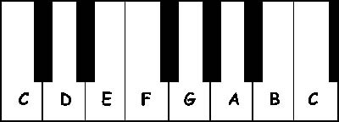

- Print 3 copies of this this dummy piano keyboard then cut the outline.
- Connect them all by overlapping the note C using a glue. (observe neatness on your work). This will make 3 octaves.
- Paste the keyboard on a folder and cut the layout.
- Plastic cover your work and do not forget to write your CN, NAME, AND YEAR & SECTION at the back

